**1. Log in the system**

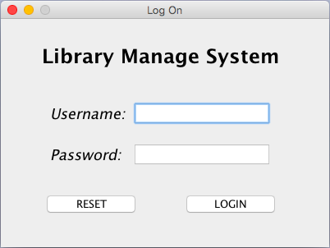

The system user can log in the system only by entering valid username and password. They cannot be null and must match the records in the USER table of library database.

**2. Main Frame**

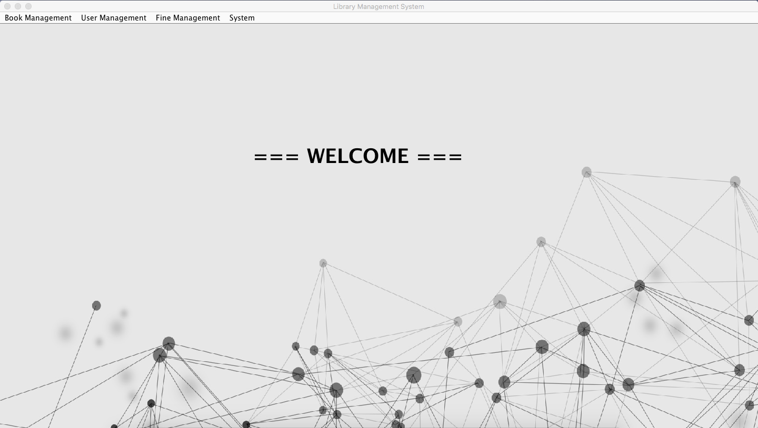

On the top portion of the main window, the menu bar shows the features of the application.

·Book Management

--- Book Search & Borrow

--- Book Search & Return

·User Management

--- Add New Borrower

--- Add New System User

·Fine Management --- Fines

·System --- Logout

**2.1 Book Search & Borrow**

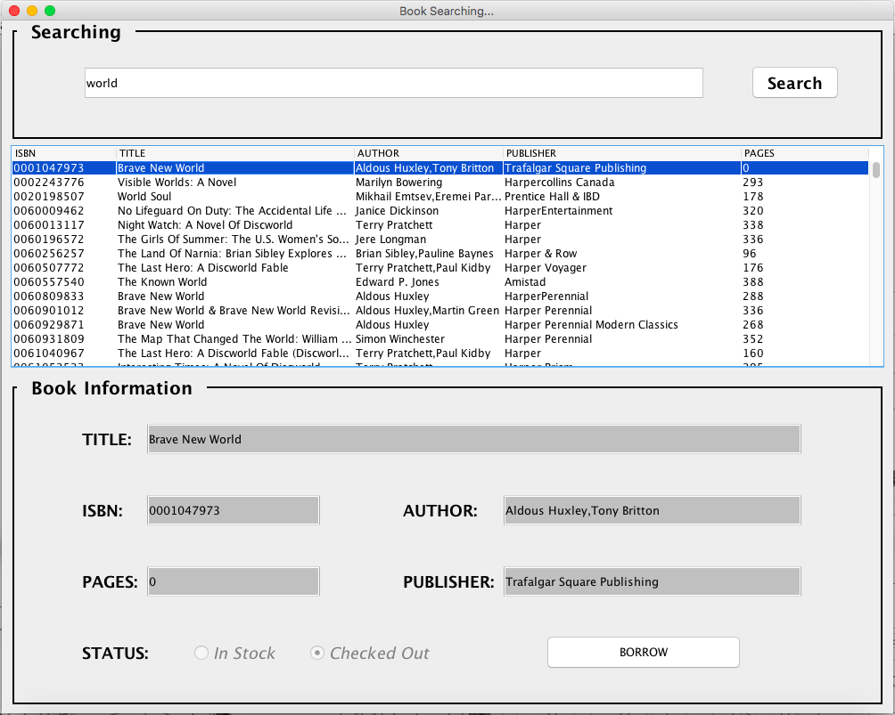

*2.1.1. Searching for book*

User can type the searching condition into the searching text field. The book can be located by the substring of its Isbn, Title or Author name. All result will be displayed on the table under the searching text field.

*2.1.2 Borrowing the book*

To borrow the book, click the row of book in the result table. Then click the borrow button to check out.

In the book information panel, the status shows the availability of the book. If the book is already checked out, then click borrow button will get an error message.

Otherwise, the user will be asked to enter the valid card_id.

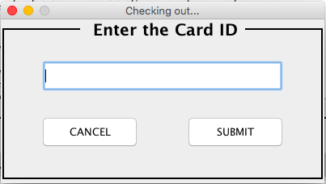

The NULL and invalid card_id will be rejected.

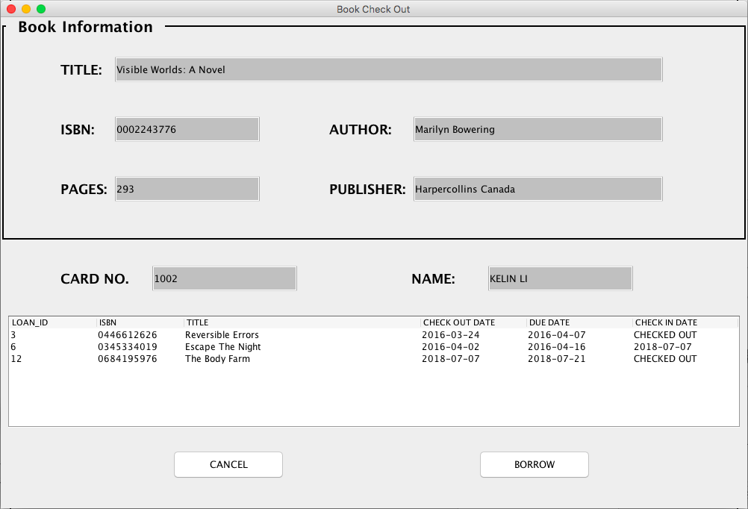

If the card_id is valid, the user will see the above window to commit to check out. The card_id and borrower name are displayed in the middle of the window. The bottom part shows all the loan records of the borrower. “CHECKED OUT” in the CHECK IN DATE column means the book haven’t been return yet. For each borrower, the maximum number of books that can borrowed is 3. If the borrower has 3 books with “CHECKED OUT” status, the action of borrowing book will be rejected.

**2.2 Book Search & Return**

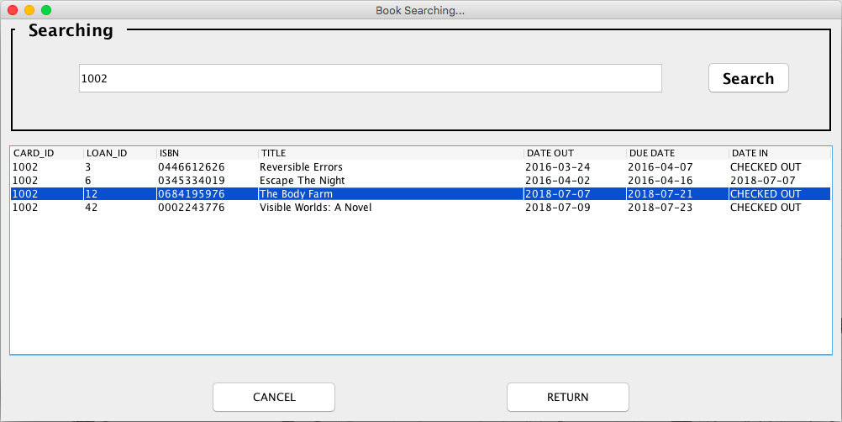

User can type the searching condition into the searching text field. The loan records can be located by the substring of book Isbn, borrower card_id or name. All result will be displayed on the table under the searching text field.

By clicking the row in the table and the return button, the user can return the specify book. The system will update the “paid” status and Date_in values of the returned book (loan record).

**2.3 Add New Borrower**

The card no of the new borrower is automatically given by system. The user must enter the SSN, borrower name and address to create a new borrower.

The SSN should be unique, which means for each SSN, it can be used to create only one borrower account.

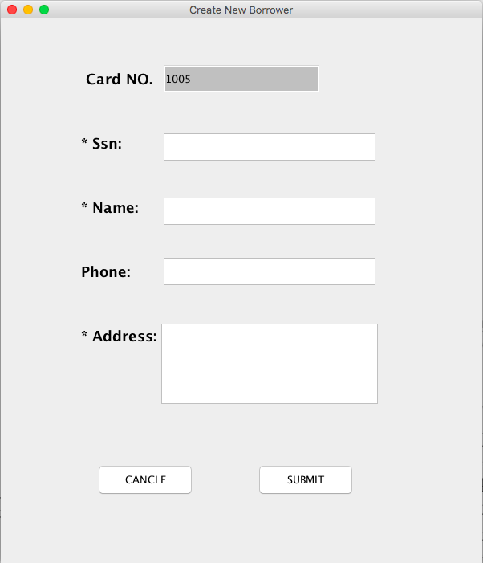

**2.4 Add New System User**

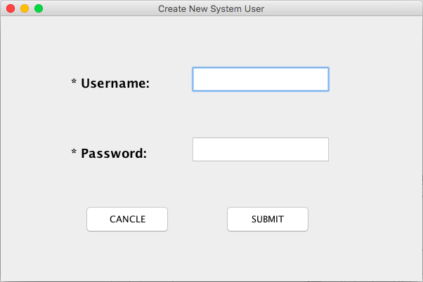

The user can create a new system user by specify the username and password. The valid username must be different from all the username in the database.

**2.5 Fines**

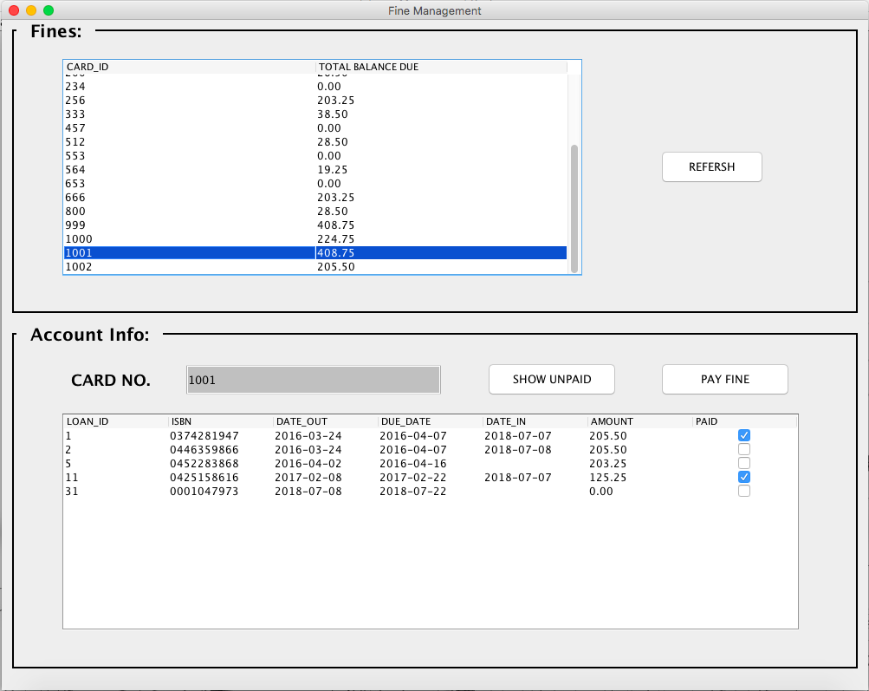

The total balance due for each borrower are shown in the table of top portion of the window. The user can click “REFRESH” button to get the up-to-date amount of each user. By clicking the row in top table, the detailed loan records will be displayed in the bottom table. All the loan records of the borrower which is selected are shown (include the records which already have been paid). Click “SHOW UNPAID” button, the paid records will be filter out. Then choose one row (one record) to pay the fine.

Note: The user only can make a payment with unpaid loans. To pay the fine, the book needs to be returned first.

**2.6 Logout**

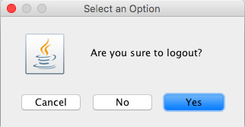

Click “logout” under System menu to safety logout.